Gunathilaka D. D. T. M. (IT13011130) (WD-SE)

4th year 2nd semester 2016

9/29/2016

SRI LANKA INSTITUTE OF INFORMATION TECHNOLOGY

FACULTY OF COMPUTING

Mini Project 2 Assignment Submission Report

DATA MINING & WAREHOUSING

The Following report describes the implementation procedure of data warehouse for “Online News Popularity” dataset. The data set summarizes a heterogeneous set of features about articles published by Mashable in a period of two years. (www.mashable.com). Data set contains information relevant to each department of the company. Therefore, a data warehouse has been implemented to integrate all those information of articles for analysis and reporting purposes.

# Table Structure

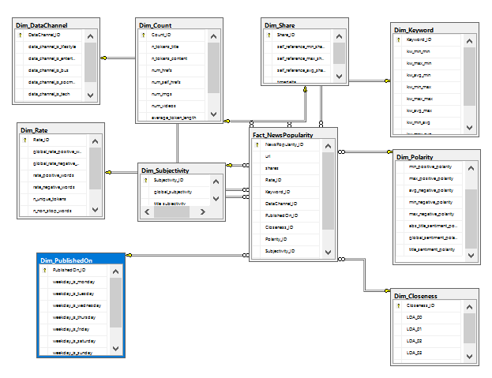In order to create data warehouse **Star schema** design methodology has been used.

## Facts table

The fact table contains measures that we take to evaluate the performance. In this case study the predicted number of shares measured given for various articles.

## Dimension tables

The dimension tables contain different perspectives that we can take measurements from respective facts table. Dimensions are taken considering articles ratios, keywords, data channel, dates, closeness, polarity, counts and shares.

The Microsoft SQL Management Studio and MSSQL server 2012 are used to create the fact and dimensions tables.

In order to keep consistency and uniquely identify dimension table record Surrogate keys are declared for dimension tables.

Create Database OnlineNewsPopularity

Go

Use OnlineNewsPopularity

Go

Dimension tables

Drop Table Dim_Rate

Go

Create Table Dim_Rate

(

Rate_ID bigint identity(1,1) not null primary key nonclustered,

global_rate_positive_words real,

global_rate_negative_words real,

rate_positive_words real,

rate_negative_words real,

n_unique_tokens real,

n_non_stop_words real,

n_non_stop_unique_tokens real

)

Go

Select * From Dim_Rate

Drop Table Dim_Keyword

Go

Create Table Dim_Keyword

(

Keyword_ID bigint identity(1,1) not null primary key nonclustered,

kw_min_min bigint,

kw_max_min bigint,

kw_avg_min real,

kw_min_max bigint,

kw_max_max bigint,

kw_avg_max real,

kw_min_avg real,

kw_max_avg real,

kw_avg_avg real

)

Go

Select * From Dim_Keyword

Drop Table Dim_DataChannel

Go

Create Table Dim_DataChannel

(

DataChannel_ID bigint identity(1,1) not null primary key nonclustered,

data_channel_is_lifestyle bigint,

data_channel_is_entertainment bigint,

data_channel_is_bus bigint,

data_channel_is_socmed bigint,

data_channel_is_tech bigint,

data_channel_is_world bigint

)

Go

Select * From Dim_DataChannel

Drop Table Dim_PublishedOn

Go

Create Table Dim_PublishedOn

(

PublishedOn_ID bigint identity(1,1) not null primary key nonclustered,

weekday_is_monday bigint,

weekday_is_tuesday bigint,

weekday_is_wednesday bigint,

weekday_is_thursday bigint,

weekday_is_friday bigint,

weekday_is_saturday bigint,

weekday_is_sunday bigint,

is_weekend bigint

)

Go

Select * From Dim_PublishedOn

Drop Table Dim_Closeness

Go

Create Table Dim_Closeness

(

Closeness_ID bigint identity(1,1) not null primary key nonclustered,

LDA_00 real,

LDA_01 real,

LDA_02 real,

LDA_03 real,

LDA_04 real

)

Go

Select * From Dim_Closeness

Drop Table Dim_Polarity

Go

Create Table Dim_Polarity

(

Polarity_ID bigint identity(1,1) not null primary key nonclustered,

avg_positive_polarity real,

min_positive_polarity real,

max_positive_polarity real,

avg_negative_polarity real,

min_negative_polarity real,

max_negative_polarity real,

abs_title_sentiment_polarity real,

global_sentiment_polarity real,

title_sentiment_polarity real

)

Go

Select * From Dim_Polarity

Drop Table Dim_Subjectivity

Go

Create Table Dim_Subjectivity

(

Subjectivity_ID bigint identity(1,1) not null primary key nonclustered,

global_subjectivity real,

title_subjectivity real,

abs_title_subjectivity real

)

Go

Select * From Dim_Subjectivity

Drop Table Dim_Count

Go

Create Table Dim_Count

(

Count_ID bigint identity(1,1) not null primary key nonclustered,

n_tokens_title bigint,

n_tokens_content bigint,

num_hrefs bigint,

num_self_hrefs bigint,

num_imgs bigint,

num_videos bigint,

average_token_length real,

num_keywords bigint

)

Go

Select * From Dim_Count

Drop Table Dim_Share

Go

Create Table Dim_Share

(

Share_ID bigint identity(1,1) not null primary key nonclustered,

self_reference_min_shares bigint,

self_reference_max_shares bigint,

self_reference_avg_sharess real,

timedelta bigint,

)

Go

Select * From Dim_Share

Facts table

Drop Table Fact_NewsPopularity

Go

Create Table Fact_NewsPopularity

(

url nvarchar(4000),

shares bigint,

Rate_ID bigint not null references Dim_Rate(Rate_ID),

Keyword_ID bigint not null references Dim_Keyword(Keyword_ID),

DataChannel_ID bigint not null references Dim_DataChannel(DataChannel_ID),

PublishedOn_ID bigint not null references Dim_PublishedOn(PublishedOn_ID),

Closeness_ID bigint not null references Dim_Closeness(Closeness_ID),

Polarity_ID bigint not null references Dim_Polarity(Polarity_ID),

Subjectivity_ID bigint not null references Dim_Subjectivity(Subjectivity_ID),

Count_ID bigint not null references Dim_Count(Count_ID),

Share_ID bigint not null references Dim_Share(Share_ID),

constraint NewsPopularity_pk primary key nonclustered

(

Rate_ID , Keyword_ID , DataChannel_ID , PublishedOn_ID ,

Closeness_ID , Polarity_ID , Subjectivity_ID , Count_ID , Share_ID

)

)

Go

Select * From Fact_NewsPopularity

# Template Configuration

The Visual Studio 2015 IDE is used to implement data integration and analysis tasks. However unlike Visual Studio 2013, 2012 or older versions Business Intelligence template comes as an extension to Visual Studio 2015. Therefore, we have to manually install it as an extension.

In Visual Studio 2015 IDE go to Tools 🡪 Extensions and Updates and in online tab (left) type “SSDT “(i.e. SSDT stands for SQL Server Data Tools) and click install “SSDTDevPack”.

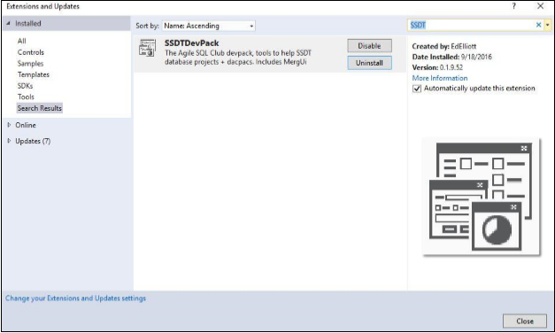

Once installation is completed restart IDE. Now we can create Business Intelligence projects in Visual Studio 2015. This contains sub project templates namely; “SQL Server Integration Service”,” SQL Server Analysis Service” and “SQL Server reporting service”.

# SQL Server Integration Services (SSIS)

The integration services help to integrate the facts and dimension tables which origin from different sources in the hospital system. Hence firstly it has to implement an Integration service project in Visual Studio. (File> New Project >Installed > Business Intelligence>Integration Services Project)

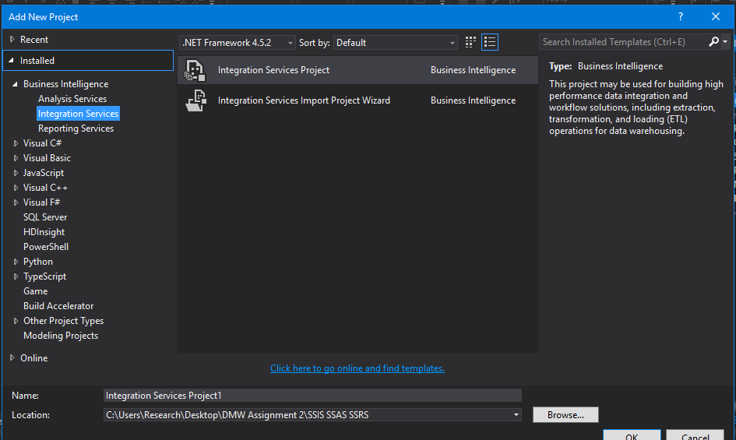

Once the project has been created add Data Flow task into Control Flow view.

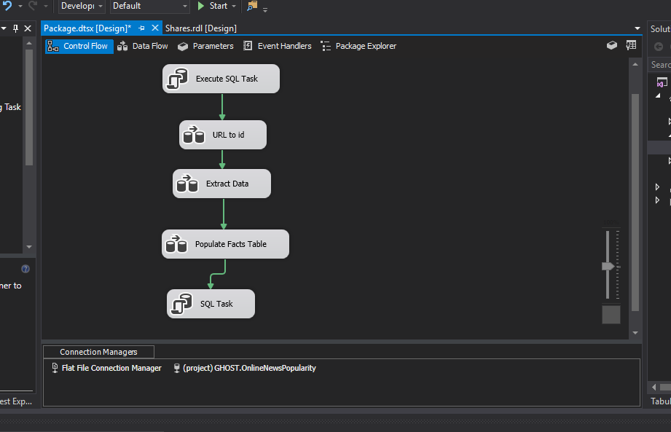

## OLEDB Database Connection with the MS SQL Server

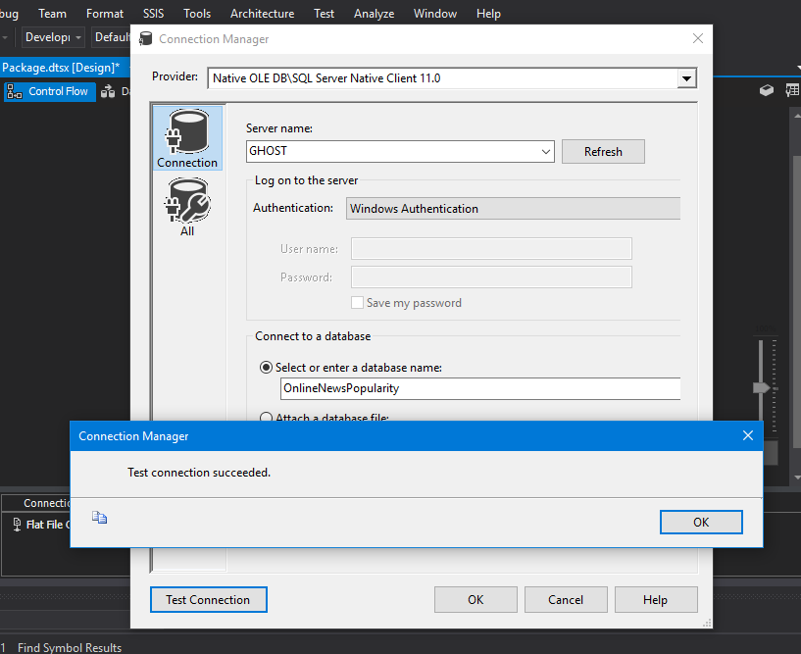

## Flat File Connection with Data Source

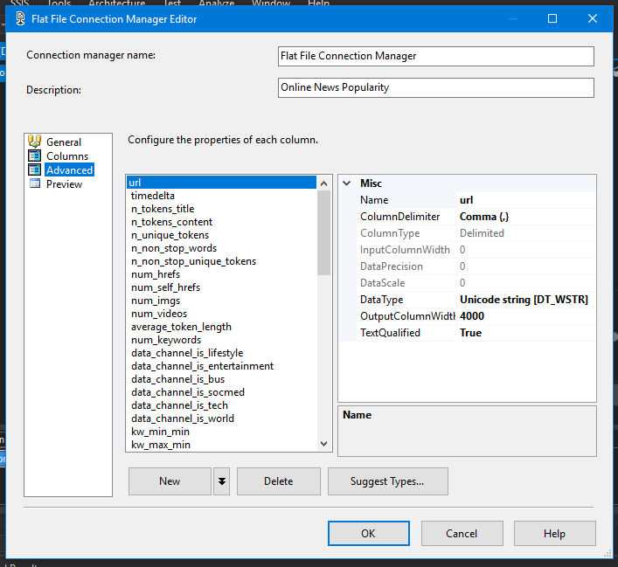

|  |  |
| --- | --- |
| Column(Type) | Data Type |
| Url | Unicode String |
| kw_min_min | four-byte signed integer |
| Int columns | four-byte unsigned integer |
| Other | float |

## Implement integration Service (SSIS)

There are No missing of null data in the data set. Dataset was identified by the url column. Therefore, identity columns implemented.

Data inserted into a temporary transaction table and identity column generated for unique urls.

Create Temporary Table

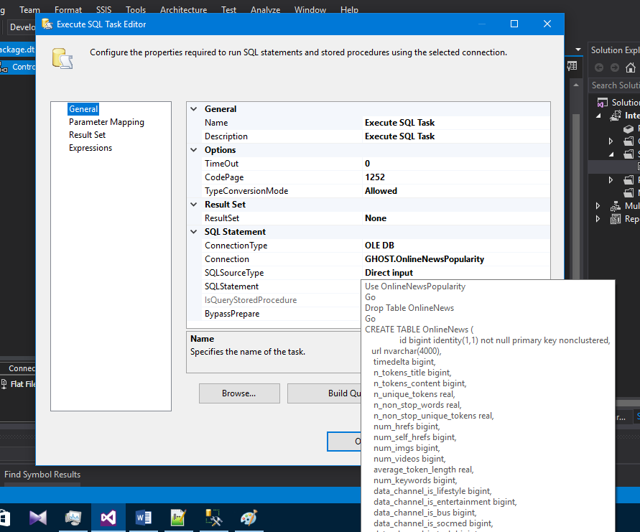

Url to ID

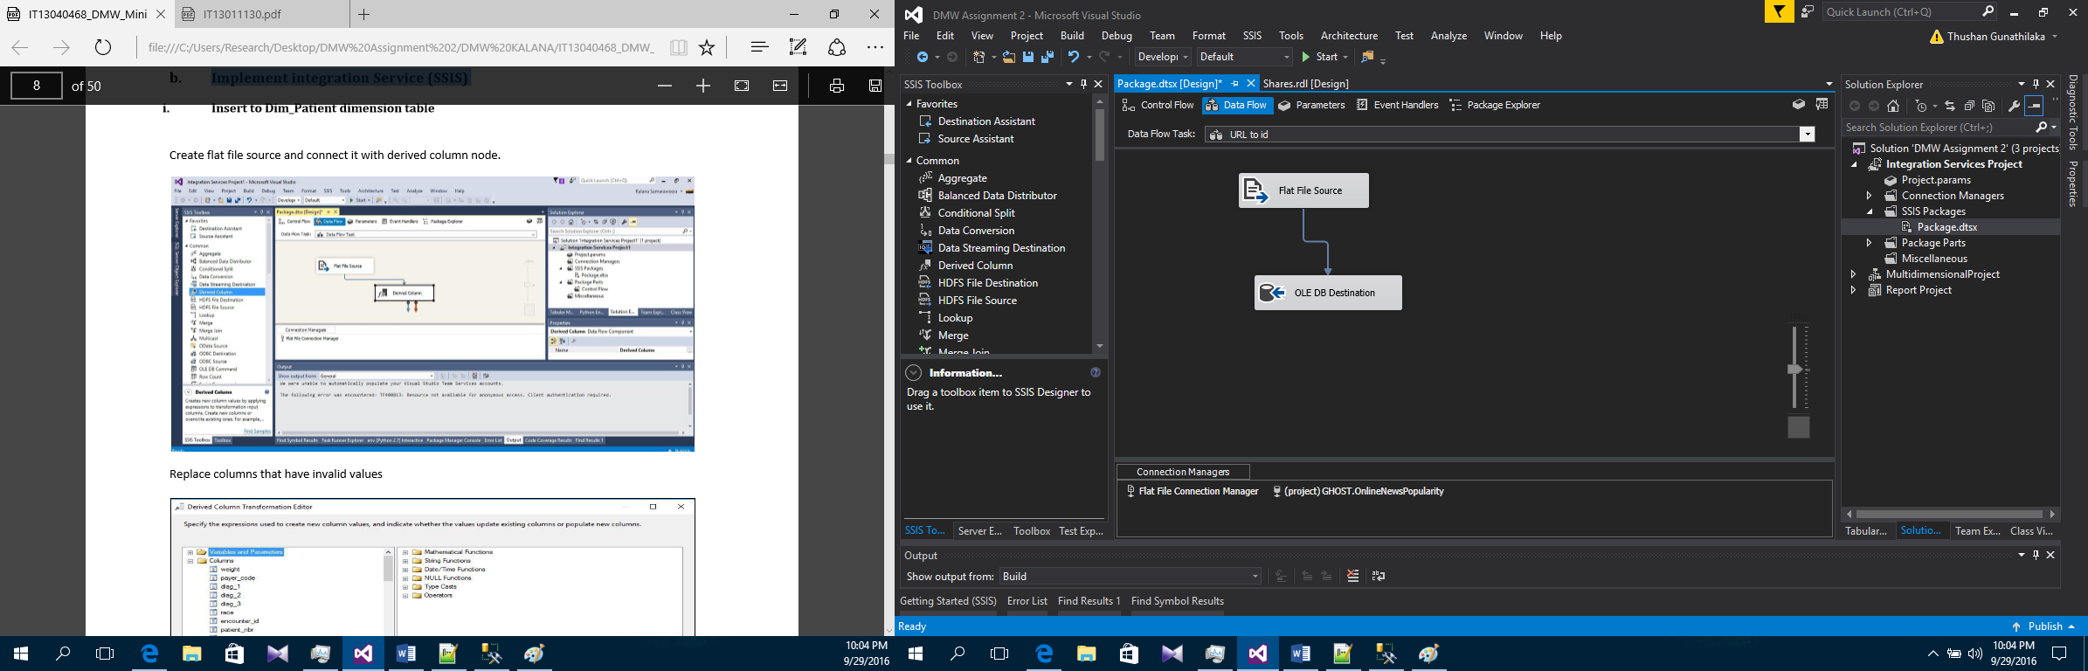

Extract Data

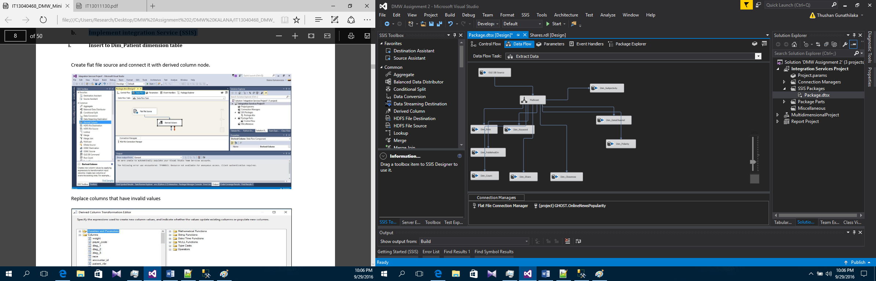

Each mapping is handled similar as below

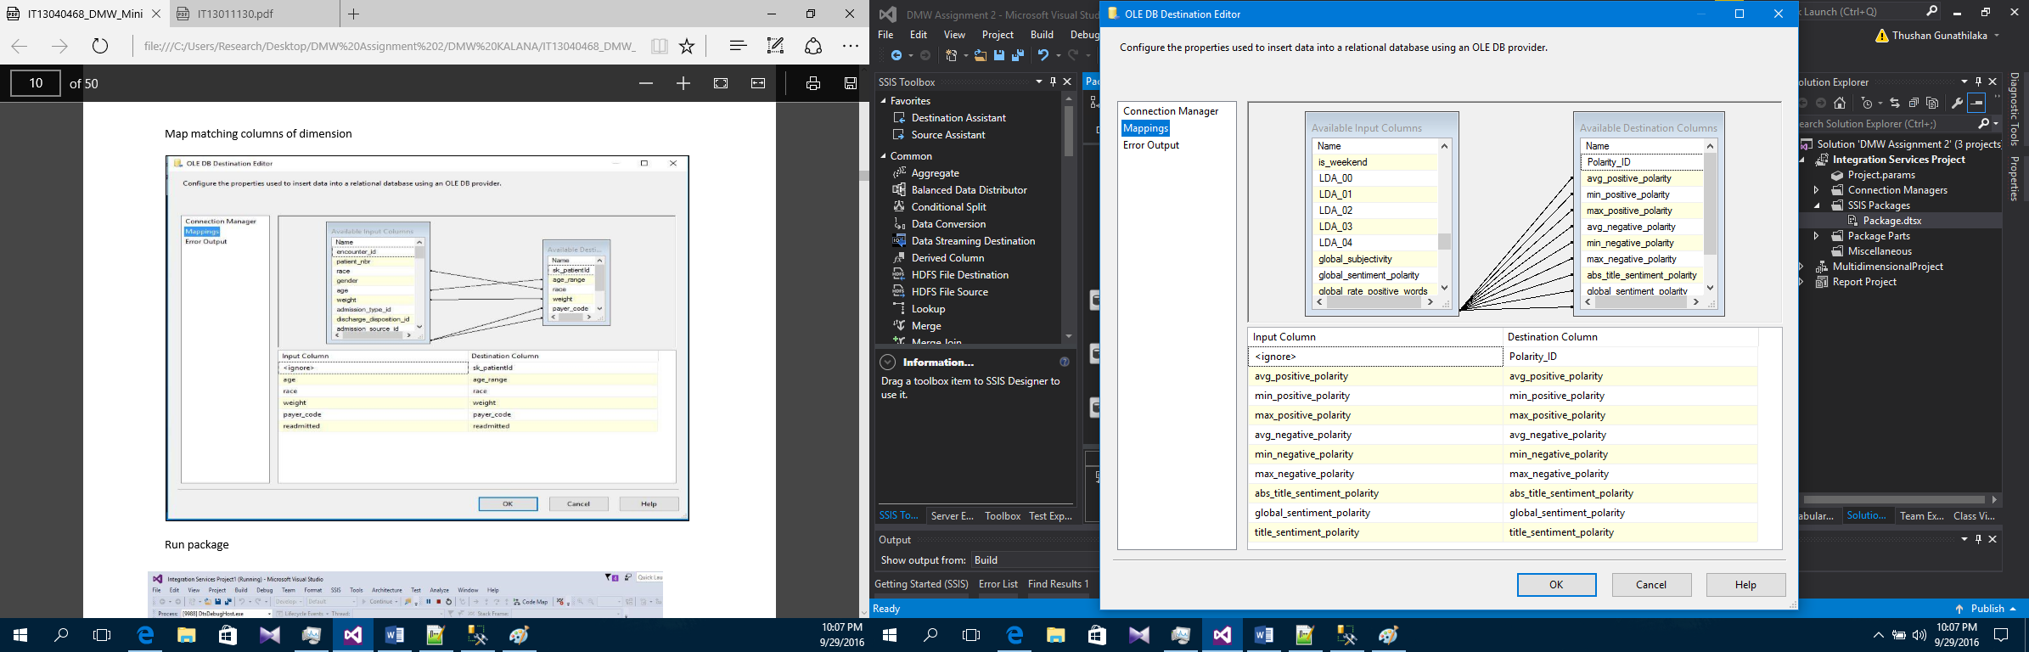

Populate Facts Table

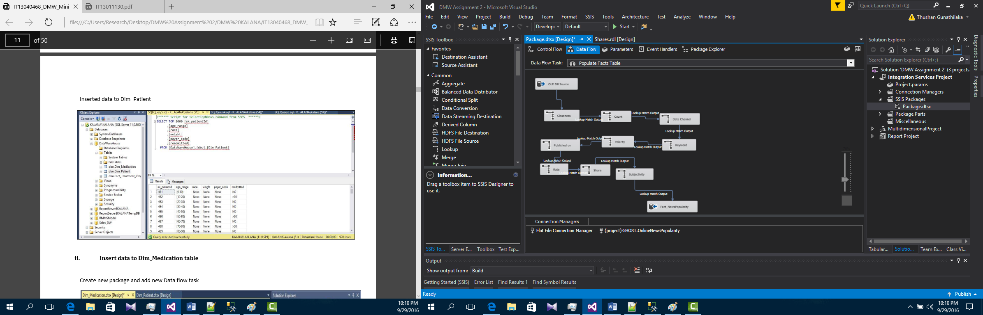

Lastly, the temporary table was dropped

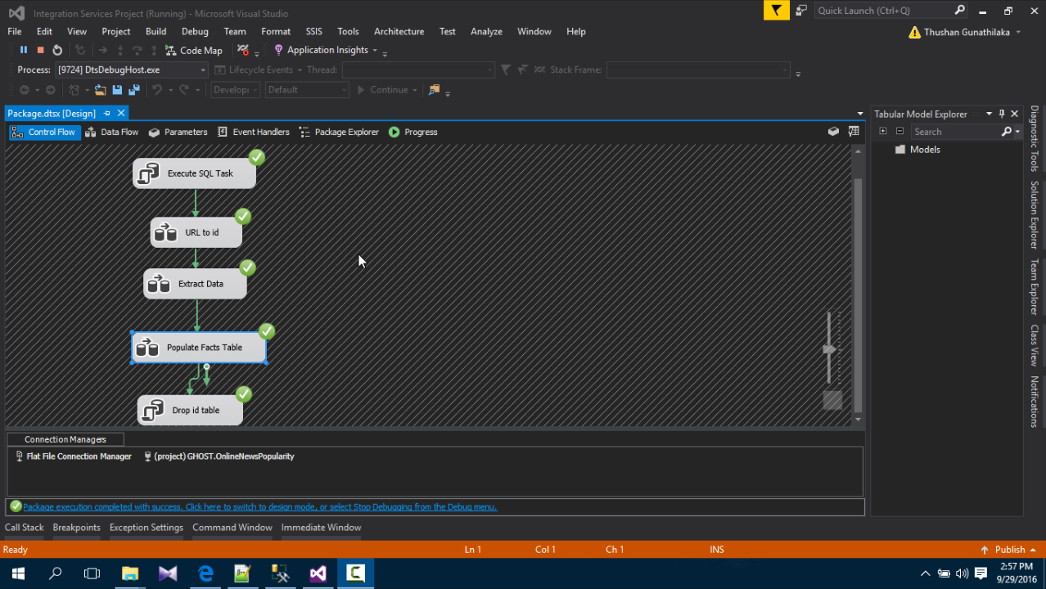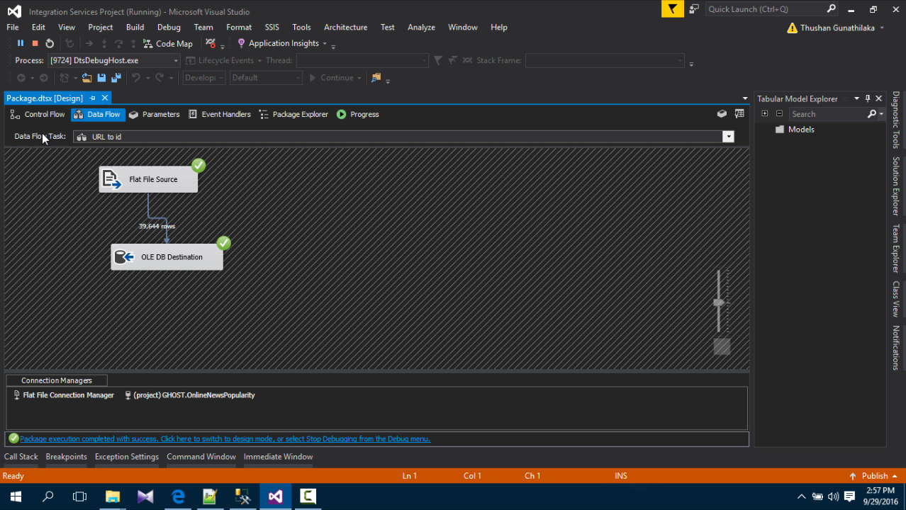

Figure 1: Url to ID

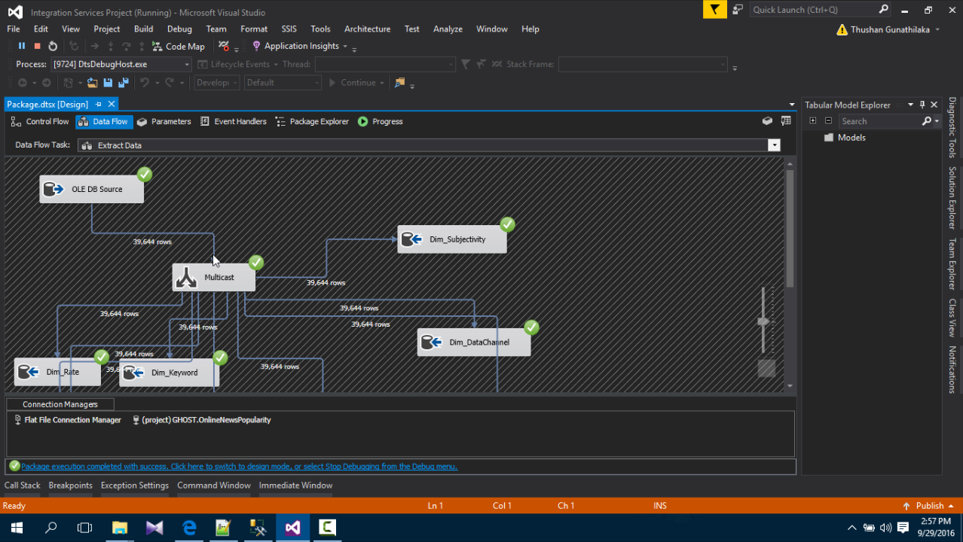

Figure 2 : Extract Data I

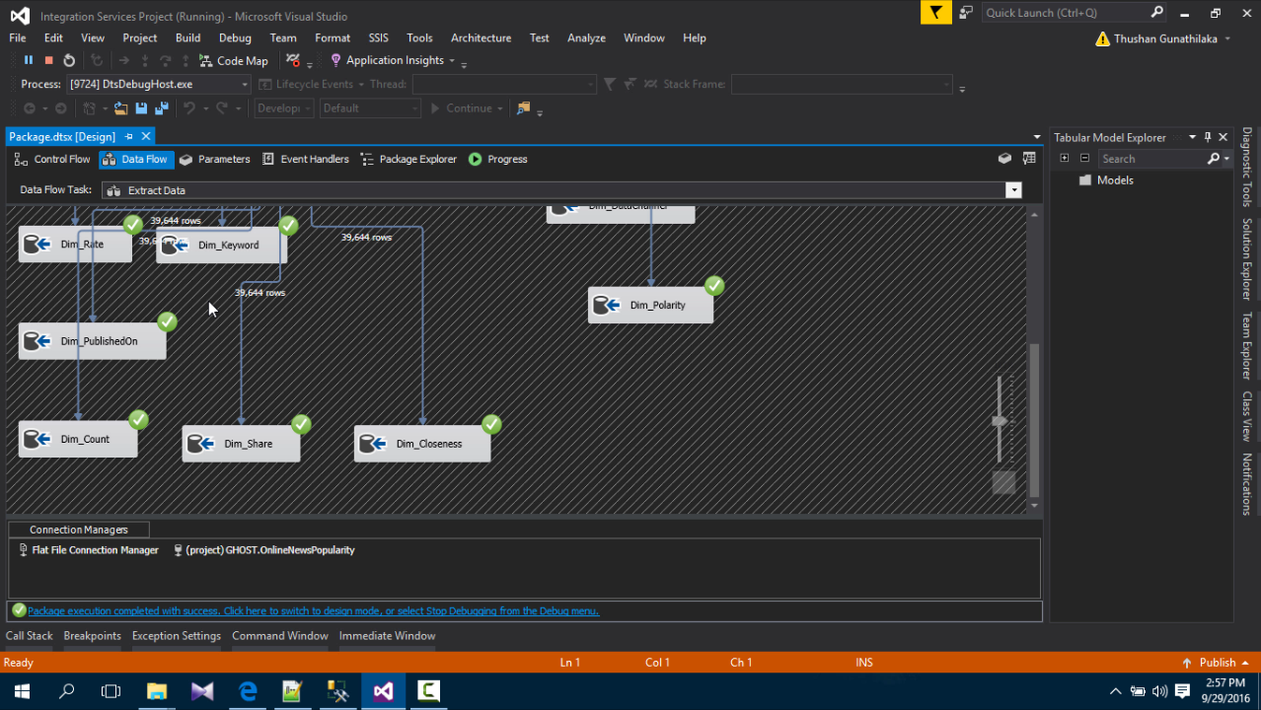

Figure 3 : Extract Data II

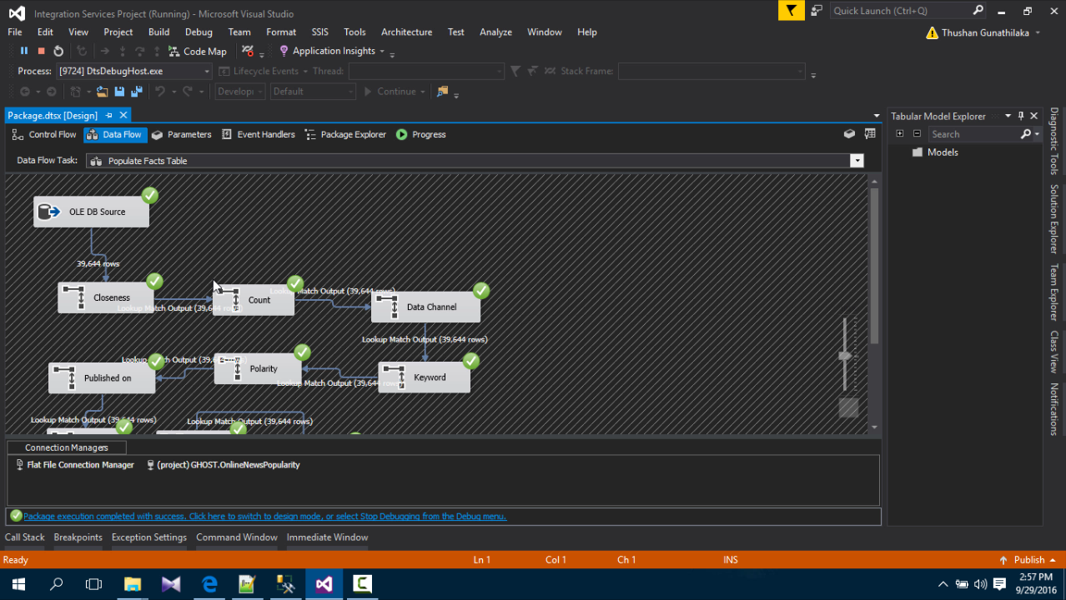

Figure 4 : Populate Fact Table I

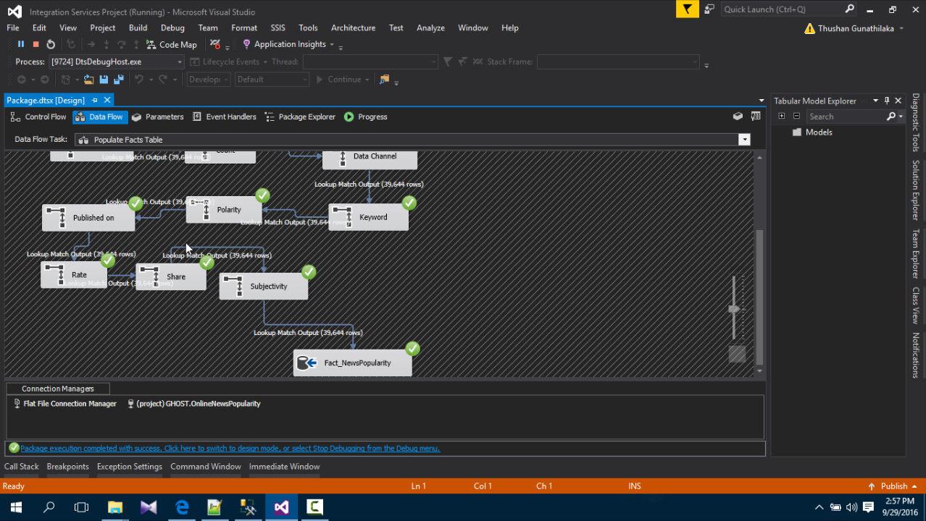

Figure 5 : Populate Fact Table II

Inserted Values to Fact Table

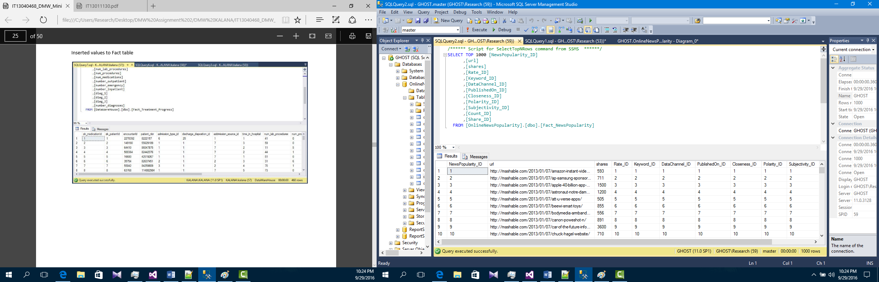

## Implement Analysis Services (SSAS)

Create new analysis project

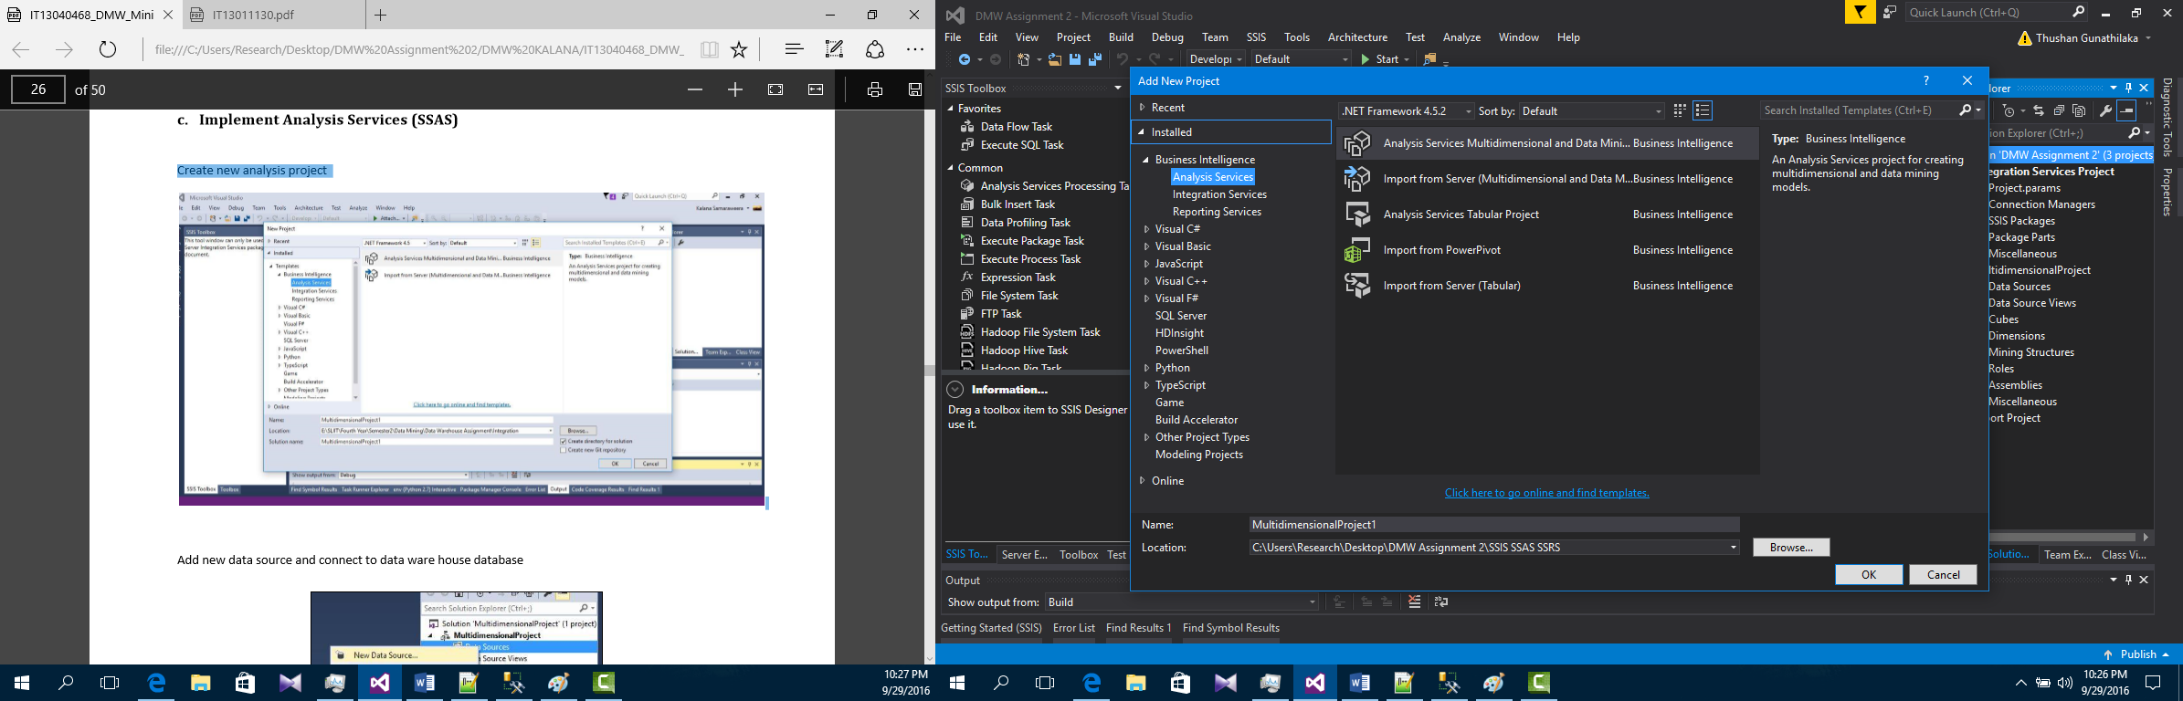

Create New Data Source with Dimensions and Fact Table

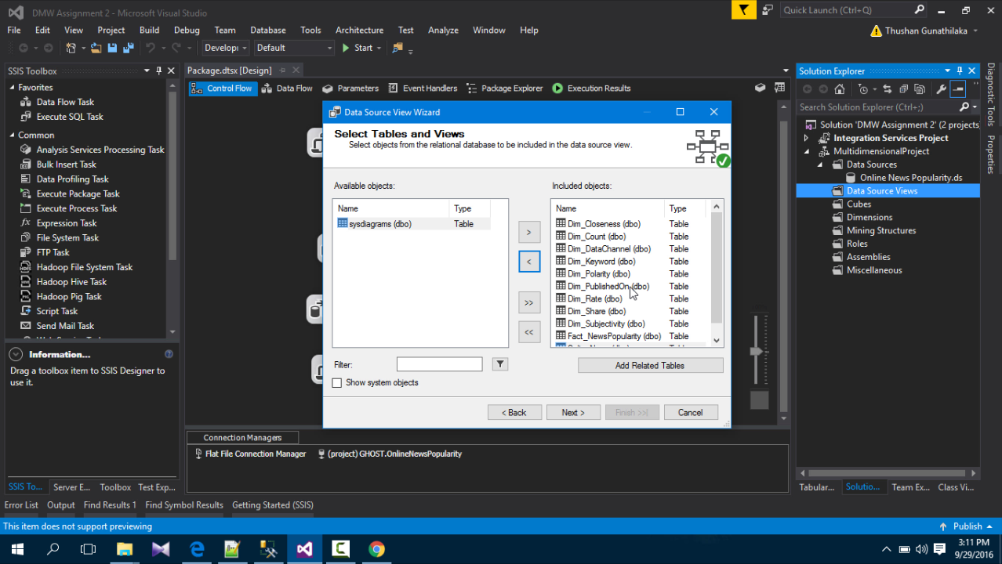

Created Schema

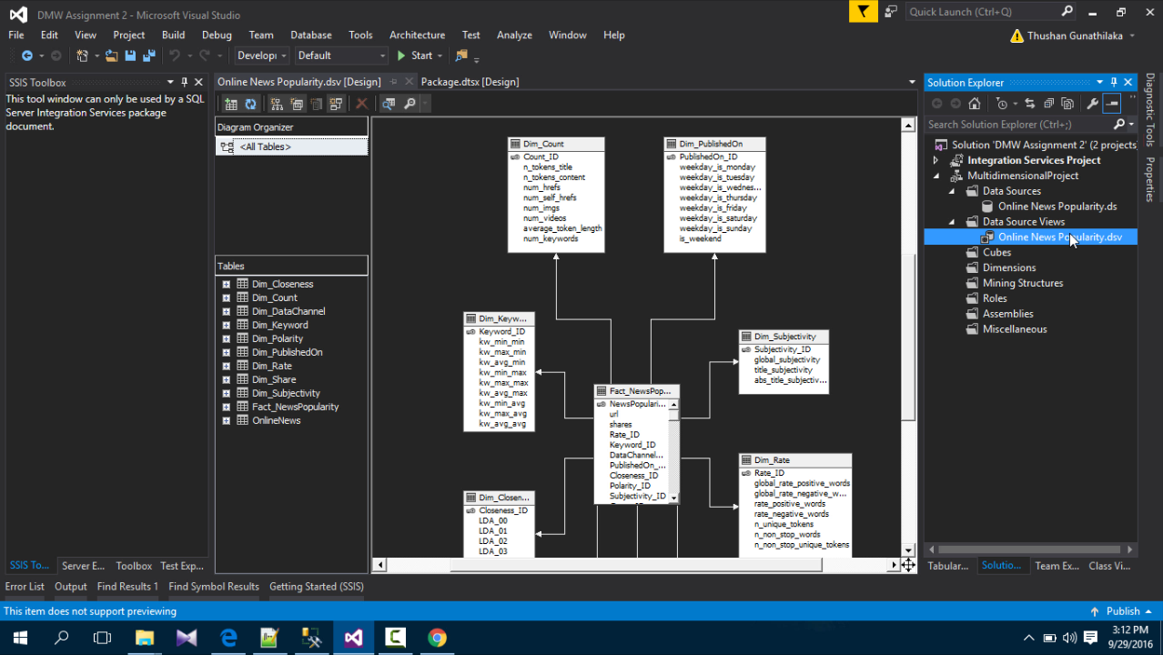

Figure 6 : Creates Schema I

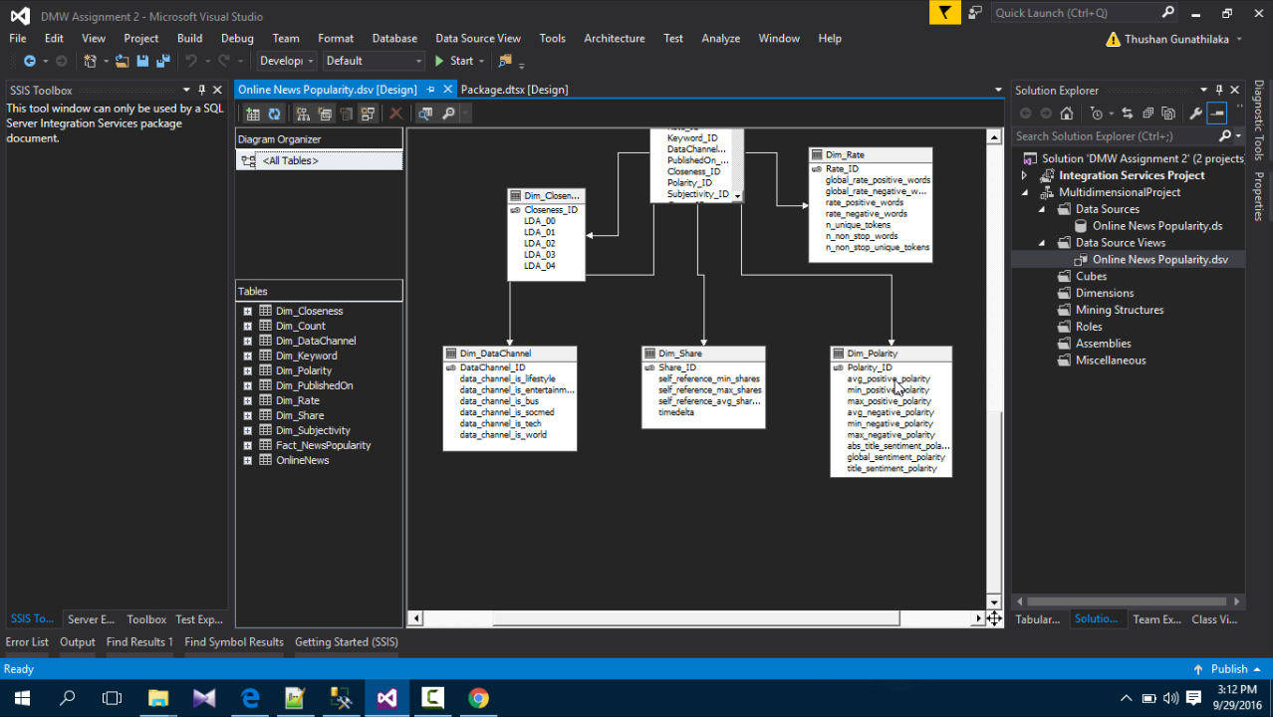

Figure 7 : Created Schema II

Create New Cube

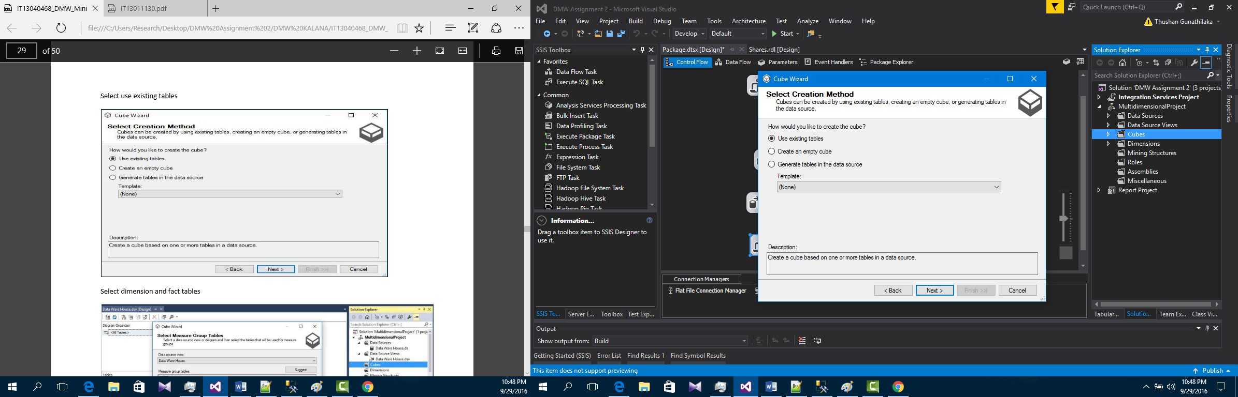

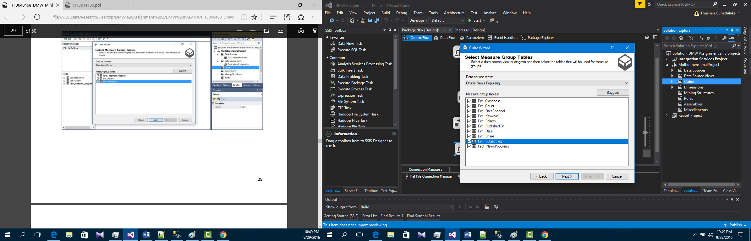

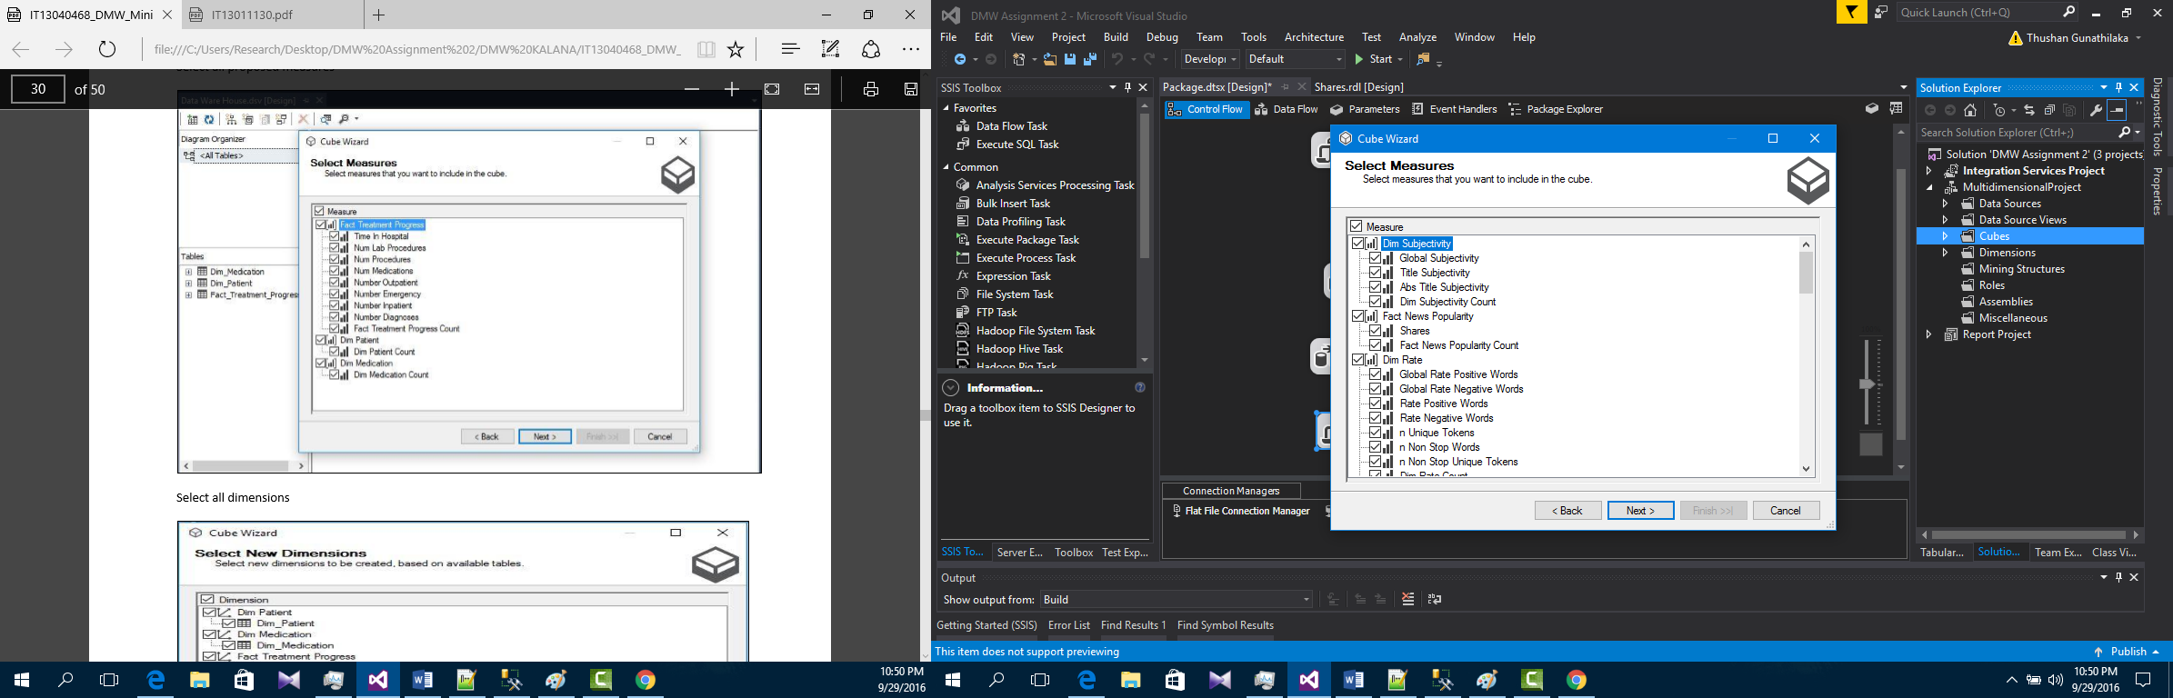

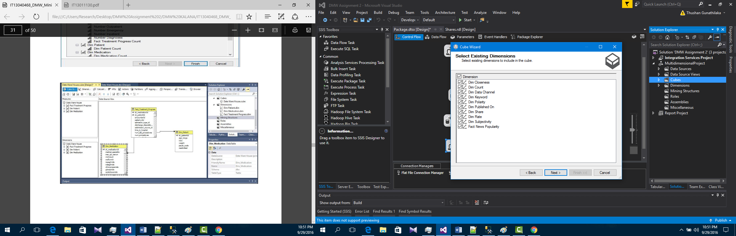

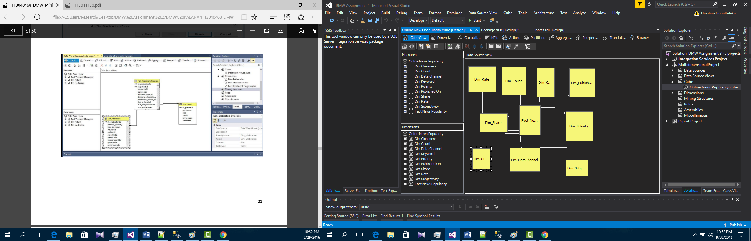

Create Mining Model

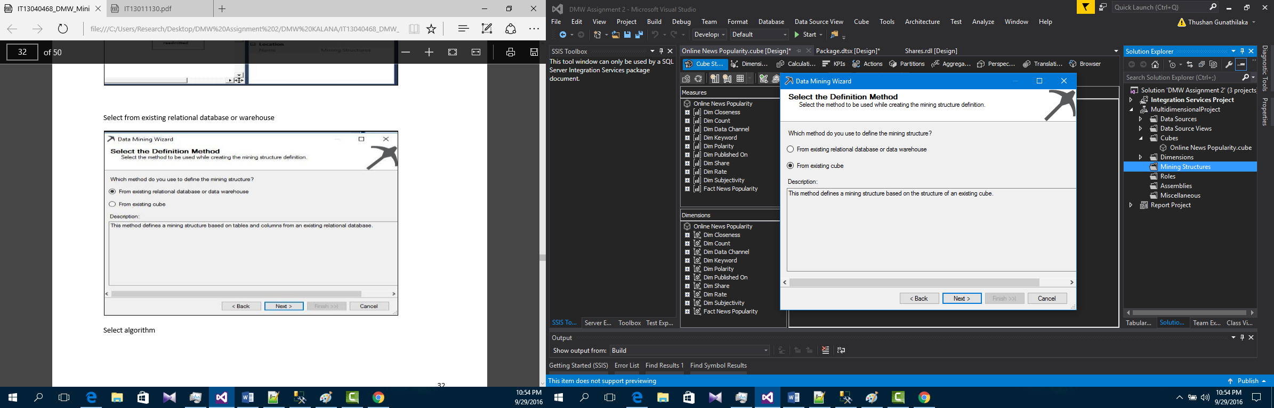

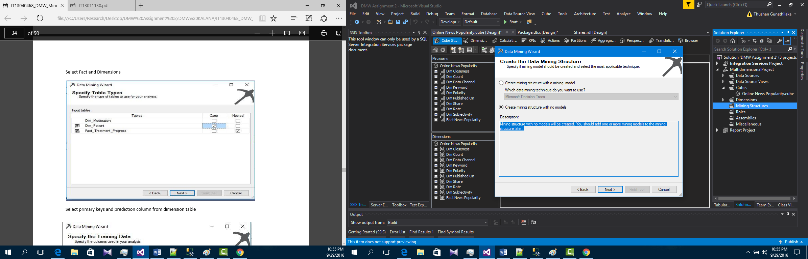

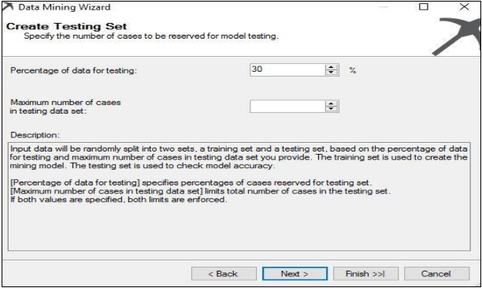

Click Finish

Deployment Settings

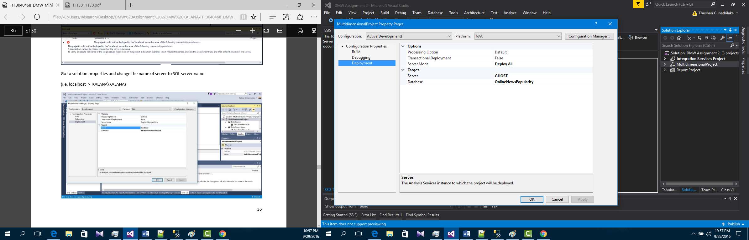

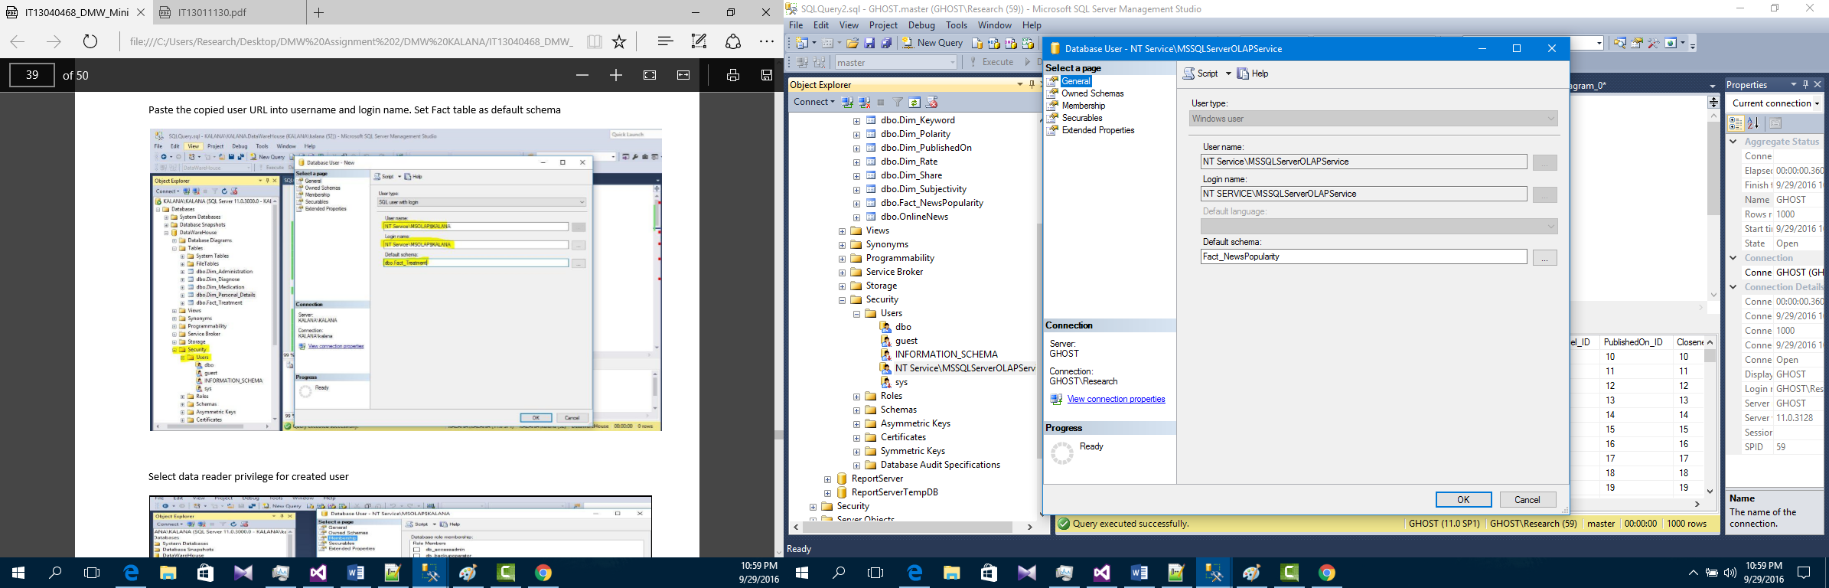

Set SSAS as Startup File

Run Solution

Visualizing Data with Power BI

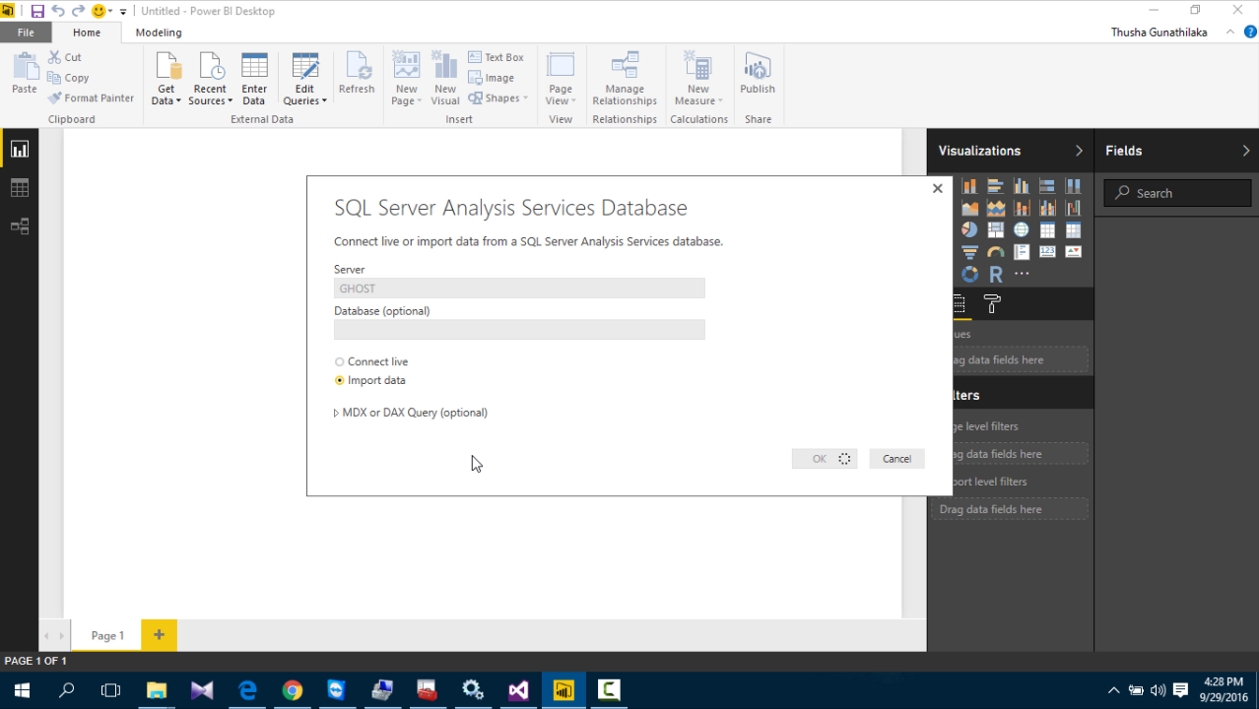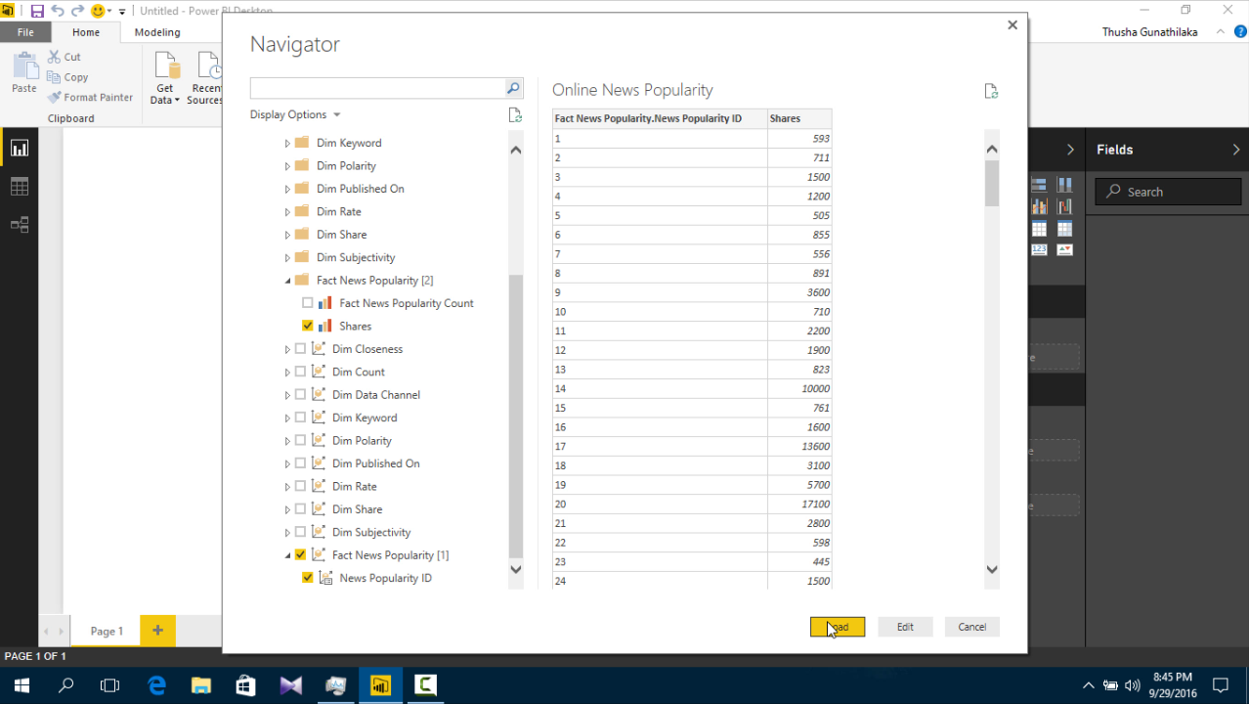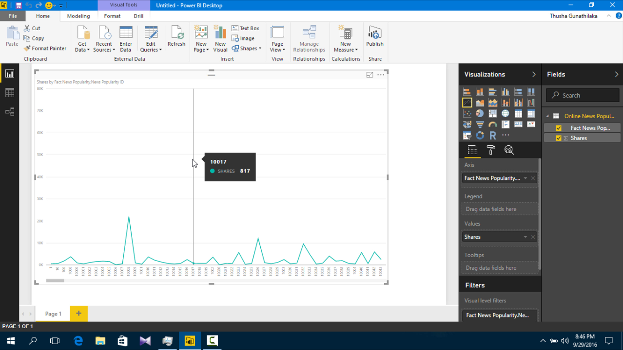

# SQL Server Reporting Services (SSRS)

Create Reporting Services project in Business Intelligence template

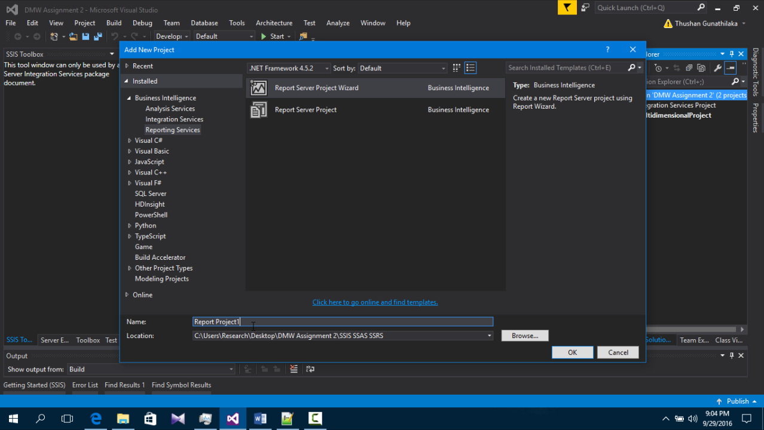

Set Data Source

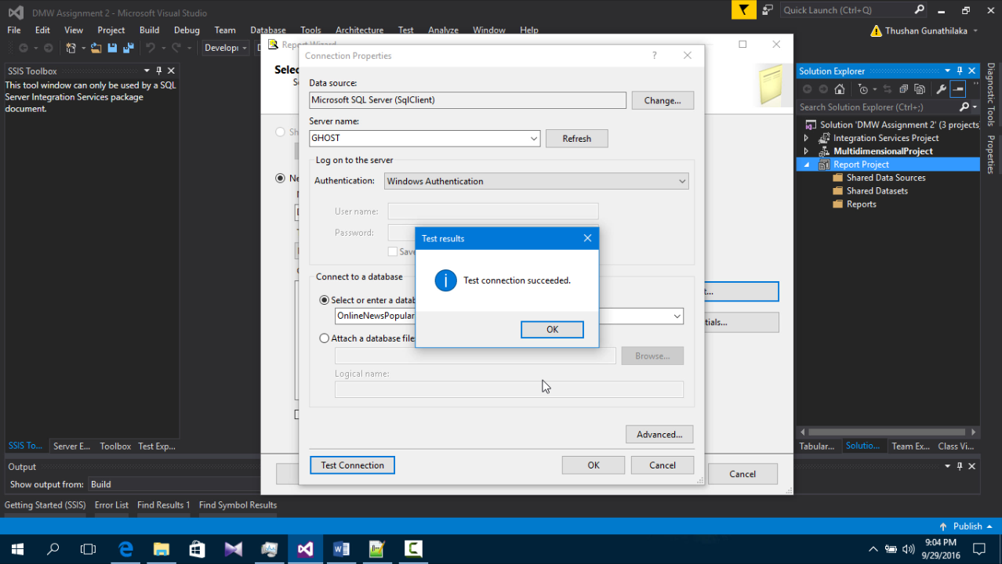

Extract Data

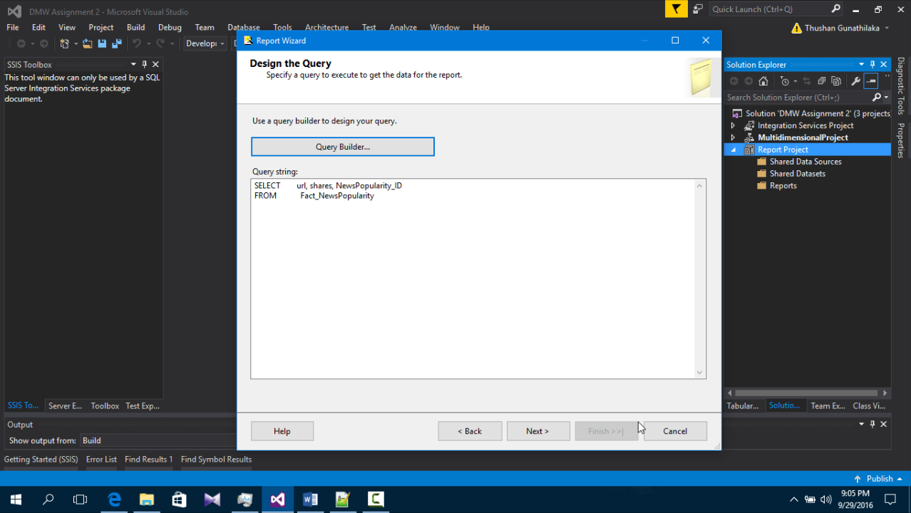

Tabular Report Sample

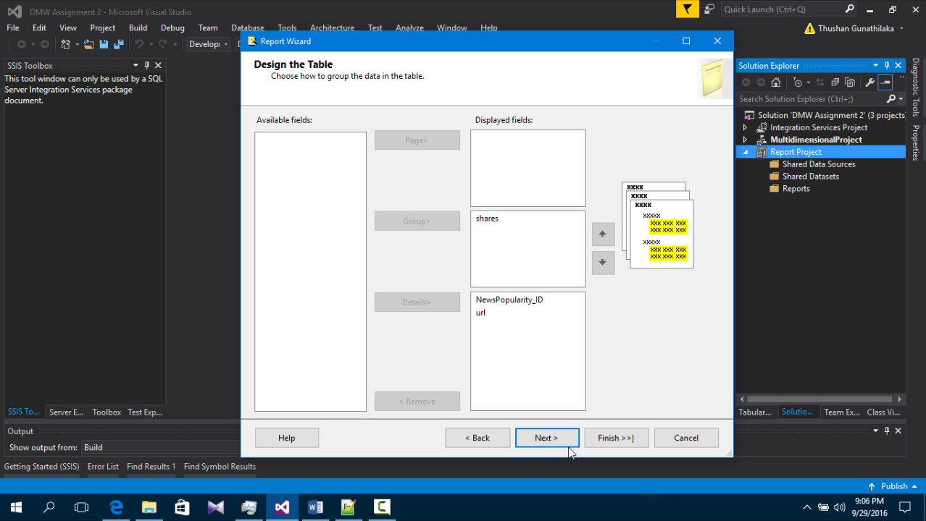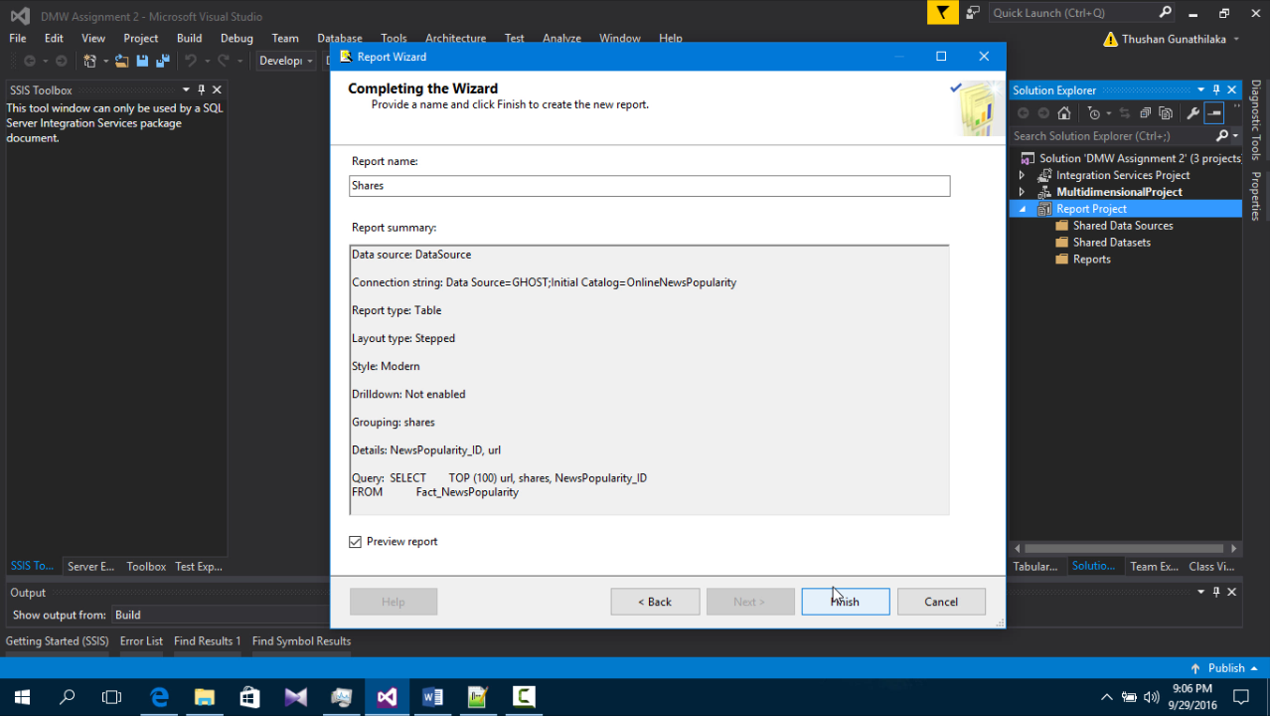

Sample Preview

